**4.1 Cells of the Nervous System\***

Neurons

* Collection of cell bodies
  + In the CNS, it is called a **nucleus**
  + In the PNS, it is called a **ganglion**
* Bundle of neurons
  + In the CNS, it is called a **tract** (only one type of information)
  + In the PNS, it is called a **nerve** (may be sensory, motor, or mixed)

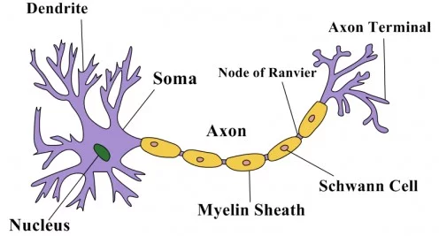

1. Soma (or cell body)
   1. Contains the nucleus, endoplasmic reticulum, ribosomes
2. Dendrites
   1. Receive incoming messages from other cells
3. Axon Hillock
   1. Integrates the incoming signals (can be excitatory or inhibitory) → initiates action potential if above threshold
4. Axon
   1. Long appendage that terminates in close proximity to a target structure (a muscle, a gland, or another neuron)
   2. Insulated by **myelin**
      1. Prevents signal loss or crossing of signal
      2. Increases speed of conduction in the axon
      3. Produced by **oligodendrocytes in the CNS**, and by **Schwann Cells in the PNS**
   3. Nodes of Ranvier → rapid signal conduction
5. Nerve terminal (or synaptic bouton)
   1. Enlarged and flattened → maximize neurotransmission to the next neuron

Other Cells in the Nervous System

* Neurons must be be supported and myelinated by **glial cells** (or neuroglia)

1. Astrocytes (star-shaped, with end feet)
   1. Structural support
   2. **Blood-brain barrier** → prevents large molecules from leaving blood to enter CNS unless they want it
   3. Gliosis → repair and starring process of the brain and spinal cord following traumatic injuries
2. Ependymal cells (simple columnar, cuboidal epithelium-like cells)
   1. Line the ventricles of the brain and produce cerebrospinal fluid (**CSF**) → shock absorber
   2. Form barrier between CSF and interstitial fluid of the tissue itself, though leaky (means doctors can sample)
3. Microglia
   1. **Phagocytic** cells that ingest and break down waste products and pathogens in the **CNS**
   2. Arise from monocytes, and are a part of the immune system which arises from the mesoderm
4. Oligodendrocytes
   1. Provide myelin sheath in the **CNS**
5. Schwann Cells
   1. Non-myelinating Schwann cells are fairly shapeless, and provide **support** for PNS axons, but do not myelinate them
   2. Normal Schwann cells **myelinate** the PNS axons
      1. Not all peripheral neurons have a myelin sheath, but most of those with a large diameter do

**4.2 Transmission of Neural Impulses\***

The Action Potential

* All-or-nothing
* Resting potential is **-70 mV**, with the inside of the neuron negative relative to the outside

1. Potassium
   1. 140 mM inside > 4 mM outside → K+ ions flow out via **potassium leak channels** (concentration gradient) → BUT some K+ ions flow back due to the attraction between K+ and the negative potential building in the cell (electric potential) → equilibrium potential of potassium is around **-90 mV**
2. Sodium
   1. 12mM inside < 145 mM outside → Na+ ions flow into the cell (concentration gradient AND electric potential) via **sodium leak channels** → equilibrium potential of sodium is around +60 mV
3. Na+/K+ ATPase
   1. **Primary active transport (since it uses ATP directly)**
   2. Continually pump sodium and potassium back to where they started → maintain their respective gradients → maintain a resting potential (since the ions leak continuously at the membrane)

Summation

1. Temporal summation (time)
2. Spatial summation (space)

Action Potential Generation

* **Voltage-gated** sodium channels have 3 states:
  + Closed
    - Closed, **de-inactivated**
    - Before the cell reaches threshold, and after inactivation has been reversed
  + Open
    - From threshold to +35 mV
  + Inactive
    - Closed, **inactivated**
    - From +35 mV to the resting potential
* **Voltage-gated** potassium channels have 2 states:
  + Closed
  + Open

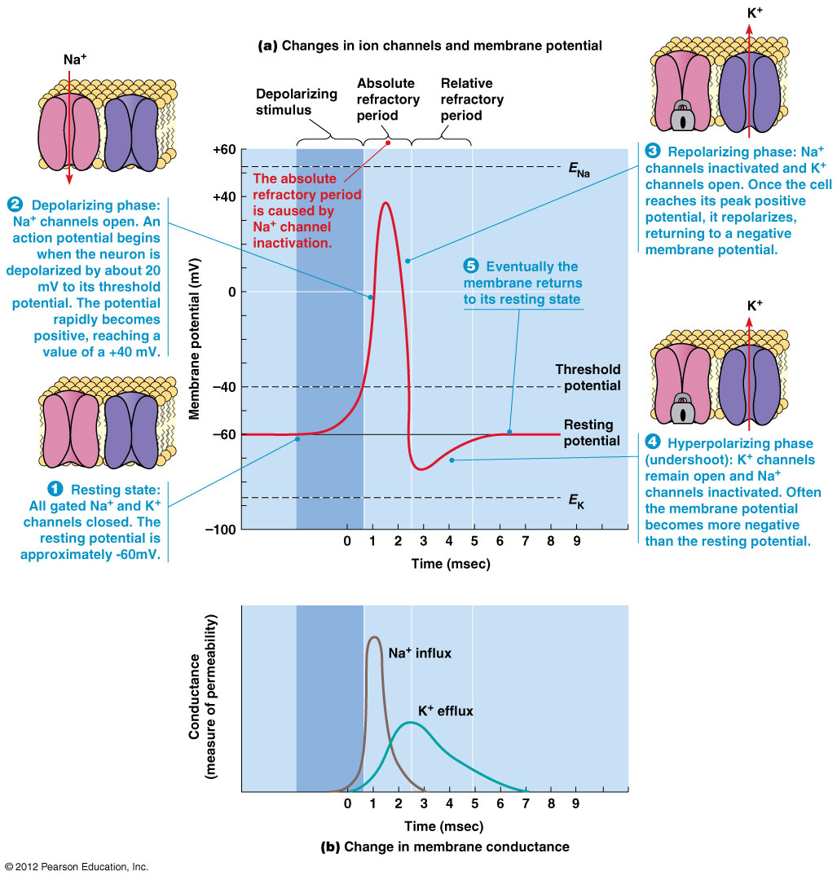

1. Absolute Refractory Period
   1. No amount of stimulation can cause another action potential to occur (because Na+ channels are **inactive** → cannot open)
2. Relative Refractory Period
   1. There must be greater than normal stimulation to cause an action potential (because Na+ channels are **closed** → ready to open)

Impulse Propagation

* One direction because the preceding segment is momentarily refractory

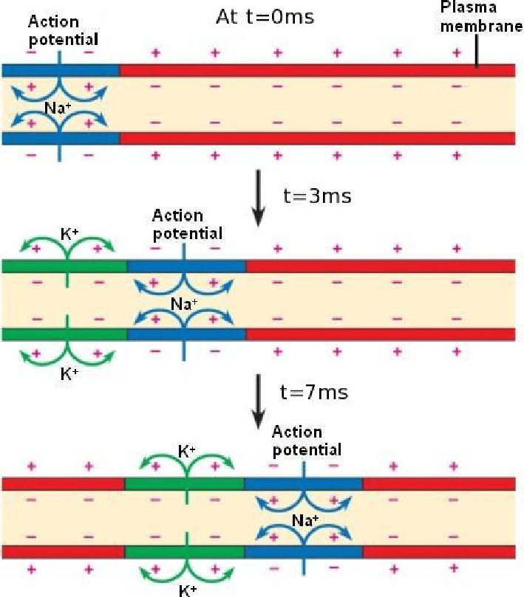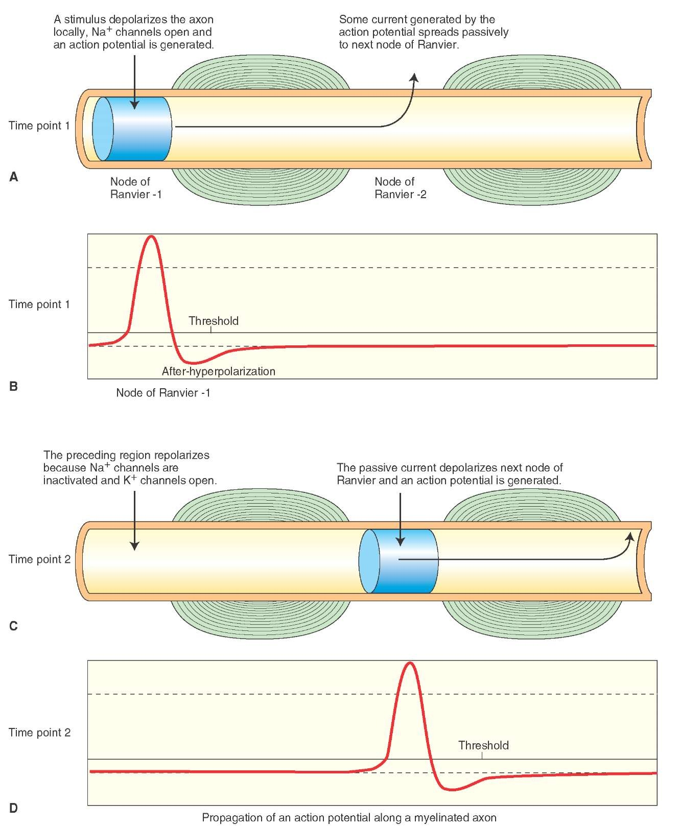

1. Increased length of axon → higher resistance → slower conduction
2. Greater cross-sectional area → decreased resistance → faster conduction
3. Myelin → good insulation → membrane is only permeable to ions at the nodes of Ranvier → saltatory conduction

The Synapse

* If the postsynaptic cell is:
  + Neuron, then it’s called **postsynaptic neuron**
  + Gland or muscle, then it’s called **effector**

**Neurotransmission process**

1. **Presynaptic neuron**: Action potential reaches the nerve terminal → VG calcium channels open → Ca2+ rush in → triggers fusion of the membrane-bound vesicles (containing neurotransmitters) with the cell membrane at the synapse → exocytosis of the neurotransmitter
2. **Synaptic cleft**: Diffusion of neurotransmitter → bind to receptors on the postsynaptic membrane
3. **Postsynaptic cell**: Depending on the neurotransmitter receptors (can be excitatory or inhibitory):
   1. Ligand-gated ion channel → depolarization or hyperpolarization
   2. G-protein coupled receptor → changes in cAMP or an influx of calcium

**Regulation of Neurotransmission** → no constant signalling to postsynaptic cell

1. Enzymatic degradation
   1. E.g. breakdown of acetylcholine (ACh) by acetylcholinesterase (AChE)
2. Reuptake carriers
   1. E.g. serotonin (5-HT), Dopamine (DA), norepinephrine (NE)
   2. There could be autoreceptors present in the presynaptic cell, signalling it to stop releasing serotonin
3. Diffusion out of the synaptic cleft
   1. E.g. Nitric oxide (NO)

**4.3 Organization of the Human Nervous System\***

Central and Peripheral Nervous Systems

**Nervous System**

* Central

1. Brain
   * + White matter: axons encased in myelin sheath
     + Gray matter: unmyelinated soma and dendrites
2. Spinal Cord
   * + Cervical, thoracic, lumbar, sacral
     + Protected by vertebral column
     + White outside, gray inside
     + Sensory neurons enter dorsally (back), motor neurons exit ventrally (front)

* Peripheral

1. Somatic - **voluntary** actions involving skin, joints, **moving muscles**
2. Autonomic - **involuntary** muscles regulating heartbeat, respiration, digestion, glandular secretions
   1. Sympathetic

* **Flight-or-flight**
  1. Parasympathetic
* **Rest-and-digest**

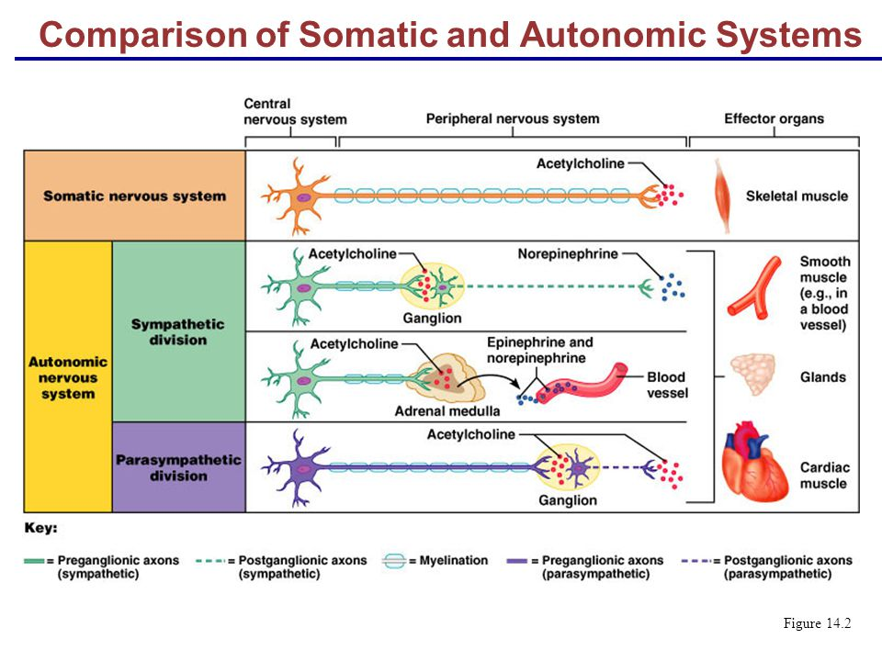

The Autonomic Nervous System

1. Parasympathetic: Long → Short
2. Sympathetic: Short → Long

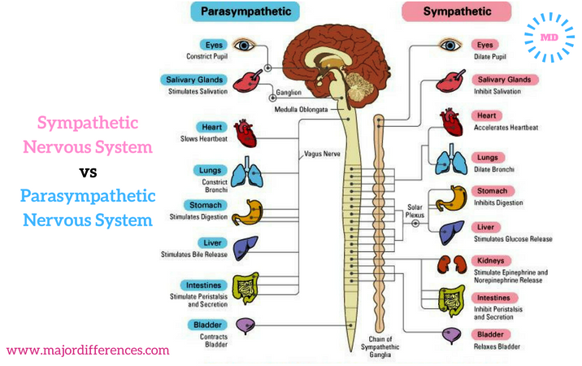

Reflexes

1. Monosynaptic reflex arc
   1. One synapse → **no interneurons**
   2. Knee-jerk reflex → protect the patellar tendon and quadriceps muscles from overstretching and tearing

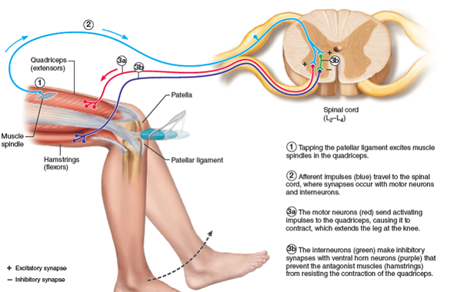

1. Polysynaptic reflex arc
   1. **At least one interneuron** between sensory and motor neurons → interneurons able to send signals to the muscles for action before the sensory information is sent to the brain
   2. E.g. right foot stepping on a nail
      1. Withdrawal reflex (similar to knee-jerk reflex) → monosynaptic → extremity of right leg will be stimulated to flex using hip muscles and hamstring muscles → pull right foot away from the nail
      2. **Interneurons quickly send signal to left leg** → left foot support the person and maintain balance